IN THE HIGH COURT OF JUSTICE Claim No: PT-2025-000910
CHANCERY DIVISION

BETWEEN:

- MOOG WOLVERHAMPTON LIMITED
(Company number 07008386)

- MOOG FERNAU LIMITED
(Company number 989895)

- MOOG READING LIMITED
(Company number 00586505)

- MOOG CONTROLS LIMITED
(Company number 01171948)
Claimants
and

- PERSONS UNKNOWN WHO FOR THE PURPOSE OF PROTEST ENTER OCCUPY OR REMAIN ON, OR DAMAGE, THE LAND AND PREMISES SHOWN EDGED RED ON PLAN 1 BEING MOOG AIRCRAFT GROUP WOLVERHAMPTON, VALIANT WAY, PENDEFORD, WOLVERHAMPTON WV9 5GB, OR WHO OBSTRUCT AND/OR INTERFERE WITH OR ATTEMPT TO OBSTRUCT AND/OR INTERFERE WITH ACCESS TO OR EGRESS FROM THAT LAND AND PREMISES

- PERSONS UNKNOWN WHO FOR THE PURPOSE OF PROTEST ENTER OCCUPY OR REMAIN ON, OR DAMAGE, THE LAND AND PREMISES SHOWN EDGED YELLOW ON PLAN 2 BEING MOOG CONTROLS LTD LUTON, UNITS C AND J AIRPORT EXECUTIVE PARK, PRESIDENT WAY, LUTON LU2 9NY, OR WHO OBSTRUCT AND/OR INTERFERE WITH OR ATTEMPT TO OBSTRUCT AND/OR INTERFERE WITH ACCESS TO OR EGRESS FROM THAT LAND AND PREMISES

- PERSONS UNKNOWN WHO FOR THE PURPOSE OF PROTEST ENTER OCCUPY OR REMAIN ON, OR DAMAGE, THE LAND AND PREMISES SHOWN EDGED YELLOW ON PLAN 3 BEING MOOG READING LIMITED, 30 SUTTONS BUSINESS PARK, READING, BERKSHIRE RG6 1AW, OR WHO OBSTRUCT AND/OR INTERFERE WITH OR ATTEMPT TO OBSTRUCT AND/OR INTERFERE WITH ACCESS TO OR EGRESS FROM THAT LAND AND PREMISES

- PERSONS UNKNOWN WHO FOR THE PURPOSE OF PROTEST ENTER OCCUPY OR REMAIN ON, OR DAMAGE, THE LAND AND PREMISES SHOWN EDGED RED ON PLAN 4 BEING MOOG AIRCRAFT GROUP TEWKSBURY, ASHCHURCH, TEWKESBURY, GLOUCESTERSHIRE GL20 8NA, OR WHO OBSTRUCT AND/OR INTERFERE WITH OR ATTEMPT TO OBSTRUCT AND/OR INTERFERE WITH ACCESS TO OR EGRESS FROM THAT LAND AND PREMISES

- PERSONS UNKNOWN WHO FOR THE PURPOSE OF PROTEST ENTER OCCUPY OR REMAIN ON, OR DAMAGE, THE LAND AND PREMISES SHOWN EDGED RED ON PLAN 5 BEING MOOG INDUSTRIAL GROUP, ASHCHURCH PARKWAY, TEWKESBURY, GLOUCESTERSHIRE GL20 8TU, OR WHO OBSTRUCT AND/OR INTERFERE WITH OR ATTEMPT TO OBSTRUCT AND/OR INTERFERE WITH ACCESS TO OR EGRESS FROM THAT LAND AND PREMISES

Defendants
_________________________________________________
[DRAFT] ORDER
_________________________________________________

PENAL NOTICE

IF YOU THE WITHIN DEFENDANTS OR PERSONS UNKNOWN OR ANY OF YOU DISOBEY THIS ORDER OR INSTRUCT OR ENCOURAGE OTHERS TO BREACH THIS ORDER YOU MAY BE HELD TO BE IN CONTEMPT OF COURT AND MAY BE IMPRISONED, FINED OR HAVE YOUR ASSETS SEIZED.
ANY OTHER PERSON WHO KNOWS OF THIS ORDER AND DOES ANYTHING WHICH HELPS OR PERMITS THE DEFENDANTS OR PERSONS UNKNOWN TO BREACH THE TERMS OF THIS ORDER MAY ALSO BE HELD IN CONTEMPT OF COURT AND MAY BE IMPRISONED, FINED OR HAVE THEIR ASSETS SEIZED.
IMPORTANT NOTICE TO THE DEFENDANTS AND PERSONS UNKNOWN
This Order prohibits you from doing the acts set out in this Order. You should read it carefully. You are advised to consult a solicitor as soon as possible. You have the right to ask the Court to vary or discharge this Order.
BEFORE the Honourable Mr/Mrs Justice [ ] on [ ] 2025
UPON the Claimants having issued this Claim by a Claim Form dated 4 September 2025
AND UPON hearing the Claimants’ having applied for an ex parte interim injunction by Application Notice dated 4 September 2025
AND UPON interim injunctive relief having been granted in part by the Honourable Mr Justice Meade on 5 September
AND UPON the Claimants seeking continuation of the interim injunctive relief granted on 5 September 2025 and further injunctive relief preventing the obstruction of or interference with access, as detailed in its application for injunctive relief of 4 September 2025 and draft Order provided therewith
AND UPON READING the Witness Statement of Elwira Kelly dated 4 September 2025 and the Second Witness Statement of Elwira Kelly dated 5 September 2025
AND UPON HEARING Timothy Morshead KC for the Claimants
AND UPON the Claimants giving and the Court accepting the undertakings set out in Schedule 1 to this Order

IT IS ORDERED THAT:
INJUNCTION
Until final disposal of the claim or further order of the court:
- The First Defendants must not:

- without the consent of the First Claimant, enter, occupy or remain on any part of the land and premises shown edged red on the first plan annexed to this Order at Schedule 2 (“Plan 1”) being Moog Aircraft Group Wolverhampton, Valiant Way, Pendeford, Wolverhampton, WV9 5GB, which for the avoidance of doubt includes the perimeter gates and fencing, including by climbing, breaking windows or external equipment, spray-painting, pouring, depositing, throwing or affixing anything, or ‘locking on’ to any part thereof by whatever means;

- obstruct or interfere with or attempt to obstruct or interfere with access to or egress from the land and premises shown edged red on Plan 1 with or without vehicles by the First Claimant, its agents, employees, contractors, customers, suppliers or other licencees;

- interfere or attempt to interfere with any of the services serving the land and premises shown edged red on Plan 1, including but not limited to water and/or sewerage pipes.

- The Second Defendants must not:

  - without the consent of the Second Claimant, enter, occupy or remain on any part of the land and premises shown edged yellow on the second plan annexed to this Order at Schedule 2 (“Plan 2”) being Moog Controls Ltd, Units C and J Airport Executive Park, President Way, Luton, LU2 9NY, including by climbing, breaking windows or external equipment, spray-painting, pouring, depositing, throwing or affixing anything, or ‘locking on’ to any part thereof by whatever means;

  - obstruct or interfere with or attempt to obstruct or interfere with access to or egress from the land and premises shown edged yellow on Plan 2 with or without vehicles by the Second Claimant, its agents, employees, contractors, customers, suppliers, or other licencees;

  - interfere or attempt to interfere with any of the services serving the land and premises shown edged yellow on Plan 2, including but not limited to water and/or sewerage pipes.

- The Third Defendants must not:

  - without the consent of the Third Claimant, enter, occupy or remain on any part of the land and premises shown edged yellow on the third plan annexed to this Order at Schedule 2 (“Plan 3”) being Moog Reading Limited, 30 Suttons Business Park, Reading, Berkshire, RG6 1AW, including by climbing, breaking windows or external equipment, spray-painting, pouring, depositing, throwing or affixing anything, or ‘locking on’ to any part thereof by whatever means);

  - obstruct or interfere with or attempt to obstruct or interfere with access to or egress from the land and premises shown edged yellow on Plan 3 with or without vehicles by the Third Claimant, its agents, employees, contractors, customers, suppliers, or other licencees;

  - interfere or attempt to interfere with any of the services serving the land and premises shown edged yellow on Plan 3, including but not limited to water and/or sewerage pipes.

- The Fourth Defendants must not:

  - without the consent of the Fourth Claimant, enter, occupy or remain on any part of the land and premises shown edged red on the fourth plan annexed to this Order at Schedule 2 (“Plan 4”) being Moog Aircraft Group Tewkesbury, Ashchurch, Tewkesbury, Gloucestershire, GL20 8NA, which for the avoidance of doubt includes the perimeter gates and fencing, including by climbing, breaking windows or external equipment, spray-painting, pouring, depositing, throwing or affixing anything, or ‘locking on’ to any part thereof by whatever means;

  - obstruct or interfere with or attempt to obstruct or interfere with access to or egress from the land and premises shown edged red on Plan 4 with or without vehicles by the Fourth Claimant, its agents, employees, contractors, customers, suppliers, or other licencees;
  - interfere or attempt to interfere with any of the services serving the land and premises shown edged red on Plan 4, including but not limited to water and/or sewerage pipes.

- The Fifth Defendants must not:

  - without the consent of the Fourth Claimant, enter, occupy or remain on any part of the land and premises shown edged red on the fifth plan annexed to this Order at Schedule 2 (“Plan 5”) being Moog Industrial Group, Ashchurch Parkway, Tewkesbury, Gloucestershire, GL20 8TU, including by climbing, breaking windows or external equipment, spray-painting, pouring, depositing, throwing or affixing anything, or ‘locking on’ to any part thereof by whatever means;

  - obstruct or interfere with or attempt to obstruct or interfere with access to or egress from the land and premises shown edged red on Plan 5 with or without vehicles by the Fourth Claimant, its agents, employees, contractors, customers, suppliers, or other licencees;

  - interfere or attempt to interfere with any of the services serving the land and premises shown edged red on Plan 5, including but not limited to water and/or sewerage pipes

- In respect of paragraphs 1 to 5, the Defendants must not (a) do it himself/herself/themselves in any other way or (b) do it by means of another person acting on his/her/their behalf, or acting on his/her/their instructions.

SERVICE AND NOTIFICATION

- Service of this Order is dispensed with, pursuant to CPR 6.28 and 81.4(2)(c).

- This Order shall be notified to the Defendants by the Claimants carrying out each of the following steps:

  - Uploading a copy of the Order on to the following website: www.moog.co.uk/injunction.

  - Affixing a copy of the Order in A4 size in a clear plastic envelope at prominent locations at each of the Sites shown edged red on Plans 1, 4 and 5 and edged yellow on Plans 2 and 3.

  - Affixing warning notices of A3 or A2 size at those locations at each of the Sites shown edged red on Plans 1, 4 and 5, and edged yellow on Plans 2 and 3, substantially in the form of the notice at Schedule 3. Any such notices which may initially be affixed in A3 size (which will, for the avoidance of doubt, be effective notification for the purposes of paragraph 14 below) shall be replaced with notices in A2 size as soon as reasonably practicable.

- Notification to the Defendants of any further applications shall be effected by the Claimants carrying out each of the following steps:

  - Uploading a copy of the application on to the following website: www.moog.co.uk/injunction

  - Affixing a notice at a prominent location at the relevant Site/s shown edged red on Plans 1, 4 and 5 and edged yellow on Plans 2 and 3 stating that the application has been made and where it can be accessed in hard copy and online.

- Notification of any further documents to the Defendants may be effected by carrying out the steps set out in paragraphs 8(i) and 8(ii) only.

- In respect of paragraphs 8 and 9 above, effective notification will be deemed to have taken place on the date for each of the Defendants on which all the relevant steps have been carried out.
- For the avoidance of doubt, in respect of the steps referred to at paragraphs 8(ii), 8(iii), and 9(ii), effective notification will be deemed to have taken place when the documents have all been first affixed regardless of whether they are subsequently removed.

VARIATION
- Anyone served with or notified of this Order may apply to the Court at any time to vary or discharge this Order or so much of it as affects that person but they must first give the Claimants 72 hours’ notice of such application. If any evidence is to be relied upon in support of the application the substance of it must be communicated in writing to the Claimants at least 48 hours in advance of any hearing.

- Any person applying to vary or discharge this Order must provide their full name, address and address for service.

- The Claimants have liberty to apply to vary this Order.
COSTS
- Costs reserved.

COMMUNICATIONS WITH THE CLAIMANTS
- The Claimants’ contact details are:
(1) Moog Aircraft Group Wolverhampton, Valiant Way, Wolverhampton, West Midlands WV9 5GB.
(2) mooglegal@moog.com.

Dated:

SCHEDULE 1 – UNDERTAKINGS

- The Claimants will comply with any order for compensation which the Court might make in the event that the Court later finds that the injunction in paragraphs 1 to 6 of this Order has caused loss to a future Defendant and the Court finds that the future Defendant ought to be compensated for that loss.

SCHEDULE 2 – PLANS
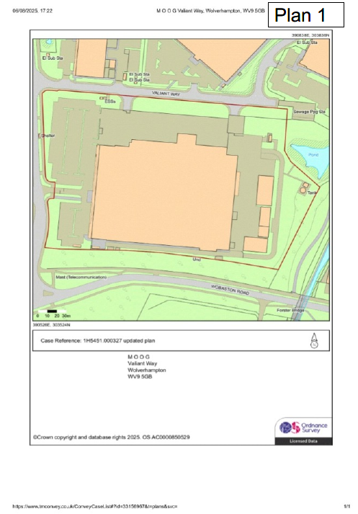

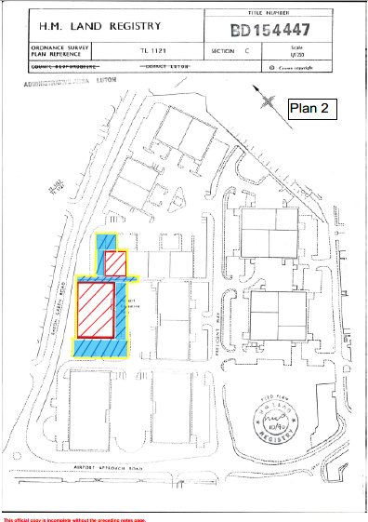

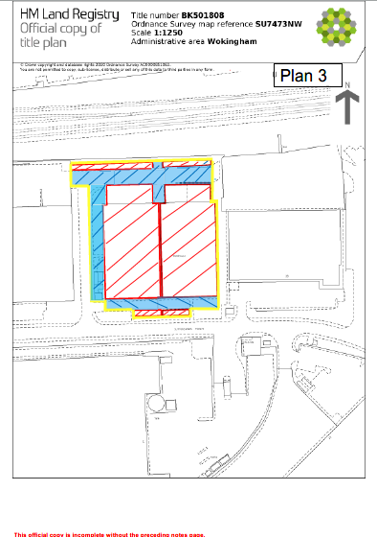

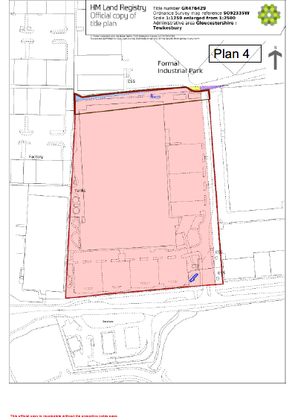

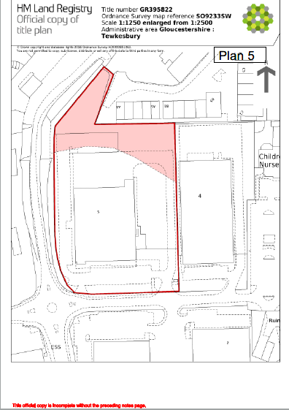

SCHEDULE 3– WARNING NOTICE
WARNING NOTICE OF COURT INJUNCTION

A HIGH COURT INJUNCTION granted by the High Court in Claim No PT-2025-000910 on exists relating to the land and premises known as Moog Aircraft Group Wolverhampton, Valiant Way, Pendeford, Wolverhampton, WV9 5GB.

The injunction means you may not:

- FOR THE PURPOSE OF PROTEST ENTER OCCUPY OR REMAIN ON THE LAND AND PREMISES SHOWN EDGED RED ON PLAN 1, INCLUDING THE PERIMETER GATES AND FENCING, BEING MOOG AIRCRAFT GROUP WOLVERHAMPTON, VALIANT WAY, WOLVERHAMPTON, WV9 5GB
- OBSTRUCT OR INTERFERE WITH OR ATTEMPT TO OBSTRUCT OR INTERFERE WITH ACCESS TO OR EGRESS FROM THE LAND AND PREMISES SHOWN EDGED RED ON PLAN 1
- INTERFERE OR ATTEMPT TO INTERFERE WITH ANY OF THE SERVICES SERVING THE LAND AND PREMISES SHOWN EGDED RED ON PLAN 1

ANYONE BREACHING THE TERMS OF THIS COURT ORDER OR ASSISTING ANY OTHER PERSON IN BREACHING THE TERMS OF THIS ORDER MAY BE HELD TO BE IN CONTEMPT OF COURT AND MAY BE SENT TO PRISON, FINED OR HAVE THEIR ASSETS SEIZED

A copy of the Order and the legal proceedings to which it relates can be viewed at www.moog.co.uk/injunction or obtained by e-mailing mooglegal@moog.com

WARNING NOTICE OF COURT INJUNCTION

A HIGH COURT INJUNCTION granted by the High Court in Claim No PT-2025-000910 on exists relating to the land and premises known as Moog Controls Ltd, Units C and J Airport Executive Park, President Way, Luton, LU2 9NY

The injunction means you may not:

- FOR THE PURPOSE OF PROTEST ENTER OCCUPY OR REMAIN ON THE LAND AND PREMISES SHOWN EDGED YELLOW ON PLAN 2 BEING MOOG CONTROLS LTD, UNITS C AND J AIRPORT EXECUTIVE PARK, PRESIDENT WAY, LUTON, LU2 9NY
- OBSTRUCT OR INTERFERE WITH OR ATTEMPT TO OBSTRUCT OR INTERFERE WITH ACCESS TO OR EGRESS FROM THE LAND AND PREMISES SHOWN EDGED YELLOW ON PLAN 2
- INTERFERE OR ATTEMPT TO INTERFERE WITH ANY OF THE SERVICES SERVING THE LAND AND PREMISES SHOWN EGDED YELLOW ON PLAN 2

ANYONE BREACHING THE TERMS OF THIS COURT ORDER OR ASSISTING ANY OTHER PERSON IN BREACHING THE TERMS OF THIS ORDER MAY BE HELD TO BE IN CONTEMPT OF COURT AND MAY BE SENT TO PRISON, FINED OR HAVE THEIR ASSETS SEIZED

A copy of the Order and the legal proceedings to which it relates can be viewed at www.moog.co.uk/injunction or obtained by e-mailing mooglegal@moog.com

WARNING NOTICE OF COURT INJUNCTION

A HIGH COURT INJUNCTION granted by the High Court in Claim No PT-2025-000910 on exists relating to the land and premises known as Moog Reading Limited, 30 Suttons Business Park, Reading, Berkshire, RG6 1AW

The injunction means you may not:

- FOR THE PURPOSE OF PROTEST ENTER OCCUPY OR REMAIN ON THE LAND AND PREMISES SHOWN EDGED YELLOW ON PLAN 3 BEING MOOG READING LIMITED, 30 SUTTONS BUSINESS PARK, READING, BERKSHIRE, RG6 1AW
- OBSTRUCT OR INTERFERE WITH OR ATTEMPT TO OBSTRUCT OR INTERFERE WITH ACCESS TO OR EGRESS FROM THE LAND AND PREMISES SHOWN EDGED YELLOW ON PLAN 3
- INTERFERE OR ATTEMPT TO INTERFERE WITH ANY OF THE SERVICES SERVING THE LAND AND PREMISES SHOWN EGDED YELLOW ON PLAN 3

ANYONE BREACHING THE TERMS OF THIS COURT ORDER OR ASSISTING ANY OTHER PERSON IN BREACHING THE TERMS OF THIS ORDER MAY BE HELD TO BE IN CONTEMPT OF COURT AND MAY BE SENT TO PRISON, FINED OR HAVE THEIR ASSETS SEIZED

A copy of the Order and the legal proceedings to which it relates can be viewed at www.moog.co.uk/injunction or obtained by e-mailing mooglegal@moog.com

WARNING NOTICE OF COURT INJUNCTION

A HIGH COURT INJUNCTION granted by the High Court in Claim No PT-2025-000910 on exists relating to the land and premises known as Moog Aircraft Group Tewkesbury, Ashchurch, Tewkesbury, Gloucestershire, GL20 8NA.

The injunction means you may not:

- FOR THE PURPOSE OF PROTEST ENTER OCCUPY OR REMAIN ON THE LAND AND PREMISES SHOWN EDGED RED ON PLAN 4, INCLUDING THE PERIMETER GATES AND FENCING, BEING MOOG AIRCRAFT GROUP TEWKESBURY, ASHCHURCH, TEWKESBURY, GLOUCESTERSHIRE, GL20 8NA
- OBSTRUCT OR INTERFERE WITH OR ATTEMPT TO OBSTRUCT OR INTERFERE WITH ACCESS TO OR EGRESS FROM THE LAND AND PREMISES SHOWN EDGED RED ON PLAN 4
- INTERFERE OR ATTEMPT TO INTERFERE WITH ANY OF THE SERVICES SERVING THE LAND AND PREMISES SHOWN EGDED RED ON PLAN 4

ANYONE BREACHING THE TERMS OF THIS COURT ORDER OR ASSISTING ANY OTHER PERSON IN BREACHING THE TERMS OF THIS ORDER MAY BE HELD TO BE IN CONTEMPT OF COURT AND MAY BE SENT TO PRISON, FINED OR HAVE THEIR ASSETS SEIZED

A copy of the Order and the legal proceedings to which it relates can be viewed at www.moog.co.uk/injunction or obtained by e-mailing mooglegal@moog.com.

WARNING NOTICE OF COURT INJUNCTION

A HIGH COURT INJUNCTION granted by the High Court in Claim No PT-2025-000910 on exists relating to the land and premises known as Moog Industrial Group, Ashchurch Parkway, Tewkesbury, Gloucestershire, GL20 8TU

The injunction means you may not:

- FOR THE PURPOSE OF PROTEST ENTER OCCUPY OR REMAIN ON THE LAND AND PREMISES SHOWN EDGED RED ON PLAN 5 BEING MOOG INDUSTRIAL GROUP, ASHCHURCH PARKWAY, TEWKESBURY, GLOUCESTERSHIRE, GL20 8TU
- OBSTRUCT OR INTERFERE WITH OR ATTEMPT TO OBSTRUCT OR INTERFERE WITH ACCESS TO OR EGRESS FROM THE LAND AND PREMISES SHOWN EDGED RED ON PLAN 5
- INTERFERE OR ATTEMPT TO INTERFERE WITH ANY OF THE SERVICES SERVING THE LAND AND PREMISES SHOWN EGDED RED ON PLAN 5

ANYONE BREACHING THE TERMS OF THIS COURT ORDER OR ASSISTING ANY OTHER PERSON IN BREACHING THE TERMS OF THIS ORDER MAY BE HELD TO BE IN CONTEMPT OF COURT AND MAY BE SENT TO PRISON, FINED OR HAVE THEIR ASSETS SEIZED

A copy of the Order and the legal proceedings to which it relates can be viewed at www.moog.co.uk/injunction or obtained by e-mailing mooglegal@moog.com:

