IN THE HIGH COURT OF JUSTICE Claim No: PT-2025-000910
BUSINESS AND PROPERTY DIVISION
PROPERTY TRUSTS AND PROBATE LIST

BETWEEN:

- MOOG WOLVERHAMPTON LIMITED
(Company number 07008386)

- MOOG FERNAU LIMITED
(Company number 989895)

- MOOG READING LIMITED
(Company number 00586505)

- MOOG CONTROLS LIMITED
(Company number 01171948)
Claimants
and

- PERSONS UNKNOWN WHO FOR THE PURPOSE OF PROTEST OR SABOTAGE ENTER OCCUPY OR REMAIN ON, OR DAMAGE, THE LAND AND PREMISES SHOWN EDGED RED ON PLAN 1 BEING MOOG AIRCRAFT GROUP WOLVERHAMPTON, VALIANT WAY, PENDEFORD, WOLVERHAMPTON WV9 5GB, OR WHO OBSTRUCT AND/OR INTERFERE WITH OR ATTEMPT TO OBSTRUCT AND/OR INTERFERE WITH ACCESS TO OR EGRESS FROM THAT LAND AND PREMISES (FIRST DEFENDANT)

- PERSONS UNKNOWN WHO FOR THE PURPOSE OF PROTEST OR SABOTAGE ENTER OCCUPY OR REMAIN ON, OR DAMAGE, THE LAND AND PREMISES SHOWN EDGED YELLOW ON PLAN 2 BEING MOOG CONTROLS LTD LUTON, UNITS C AND J AIRPORT EXECUTIVE PARK, PRESIDENT WAY, LUTON LU2 9NY, OR WHO OBSTRUCT AND/OR INTERFERE WITH OR ATTEMPT TO OBSTRUCT AND/OR INTERFERE WITH ACCESS TO OR EGRESS FROM THAT LAND AND PREMISES (SECOND DEFENDANT)

- PERSONS UNKNOWN WHO FOR THE PURPOSE OF PROTEST OR SABOTAGE ENTER OCCUPY OR REMAIN ON, OR DAMAGE, THE LAND AND PREMISES SHOWN EDGED YELLOW ON PLAN 3 BEING MOOG READING LIMITED, 30 SUTTONS BUSINESS PARK, READING, BERKSHIRE RG6 1AW, OR WHO OBSTRUCT AND/OR INTERFERE WITH OR ATTEMPT TO OBSTRUCT AND/OR INTERFERE WITH ACCESS TO OR EGRESS FROM THAT LAND AND PREMISES (THIRD DEFENDANT)

- PERSONS UNKNOWN WHO FOR THE PURPOSE OF PROTEST OR SABOTAGE ENTER OCCUPY OR REMAIN ON, OR DAMAGE, THE LAND AND PREMISES SHOWN EDGED RED ON PLAN 4 BEING MOOG AIRCRAFT GROUP TEWKSBURY, ASHCHURCH, TEWKESBURY, GLOUCESTERSHIRE GL20 8NA, OR WHO OBSTRUCT AND/OR INTERFERE WITH OR ATTEMPT TO OBSTRUCT AND/OR INTERFERE WITH ACCESS TO OR EGRESS FROM THAT LAND AND PREMISES (FOURTH DEFENDANT)

- PERSONS UNKNOWN WHO FOR THE PURPOSE OF PROTEST OR SABOTAGE ENTER OCCUPY OR REMAIN ON, OR DAMAGE, THE LAND AND PREMISES SHOWN EDGED RED ON PLAN 5 BEING MOOG INDUSTRIAL GROUP, ASHCHURCH PARKWAY, TEWKESBURY, GLOUCESTERSHIRE GL20 8TU, OR WHO OBSTRUCT AND/OR INTERFERE WITH OR ATTEMPT TO OBSTRUCT AND/OR INTERFERE WITH ACCESS TO OR EGRESS FROM THAT LAND AND PREMISES (FIFTH DEFENDANT)

- HANAH YUN STEVENS (SIXTH DEFENDANT)

- BEA SHERMAN (ALSO KNOWN AS FRANK SHERMAN) (SEVENTH DEFENDANT)

- IAIN EVANS (EIGHTH DEFENDANT)

- HISHAM ALKHAMESI (NINTH DEFENDANT)
Defendants
_________________________________________________
[DRAFT] ORDER
_________________________________________________

PENAL NOTICE

IF YOU ARE A PERSON WITHIN THE CATEGORIES OF DEFENDANTS MENTIONED ABOVE, OR ANY ONE OF THE NAMED DEFENDANTS (TOGETHER THE “DEFENDANTS”) DISOBEY THIS ORDER OR INSTRUCT OTHERS TO BREACH THIS ORDER YOU MAY BE HELD TO BE IN CONTEMPT OF COURT AND MAY BE IMPRISONED, FINED OR HAVE YOUR ASSETS SEIZED.
ANY OTHER PERSON WHO KNOWS OF THIS ORDER AND DOES ANYTHING WHICH HELPS OR PERMITS THE DEFENDANTS OR PERSONS UNKNOWN TO BREACH THE TERMS OF THIS ORDER MAY ALSO BE HELD IN CONTEMPT OF COURT AND MAY BE IMPRISONED, FINED OR HAVE THEIR ASSETS SEIZED.
IMPORTANT NOTICE TO THE DEFENDANTS AND PERSONS UNKNOWN
This Order prohibits you from doing the acts set out in this Order. You should read it carefully. You are advised to consult a solicitor as soon as possible. You have the right to ask the Court to vary or discharge this Order.
BEFORE on 2026
UPON the Claimants having issued this Claim by a Claim Form dated 4 September 2025
AND UPON the Claimants having applied for an ex parte interim injunction by Application Notice dated 4 September 2025
AND UPON interim injunctive relief having been granted in part by the Honourable Mr Justice Meade on 5 September 2025
AND UPON continuation of the interim injunctive relief granted on 5 September 2025 and further injunctive relief preventing the obstruction of or interference with access, as detailed in the Claimants’ application for injunctive relief of 4 September 2025 and draft Order provided therewith, being granted by the Honourable Mr Justice Thompsell on 6 October 2025 (the “Injunction Order”)
AND UPON the Claimant making an application by way of an Application Notice dated 2 October 2026 to add Hanah Yun Stevens, Bea Sherman (also known as Frank Sherman), Iain Evans, and Hisham Alkhamesi as sixth, seventh, eighth and ninth Defendants (respectively) to the Claim and to further amend the Re-Amended Claim Form and Re-Amended Particulars of Claim accordingly (“the Application”)
AND UPON the Claimants having applied for permission to serve the Application and other documents in this claim on the Sixth, Seventh, Eighth and Ninth Defendants by an Application Notice dated 28 July 2026 and such permission having been granted by Master McQuail by order dated 3 September 2026
AND UPON the Claimant having applied for a review of the Injunction Order by application notice dated 28 July 2026 and, if required by the court, the Application (together “the Review Application”)
AND UPON the Court being satisfied that the Review Application and other documents have been notified to the First to Fifth Defendants in accordance with paragraphs 10 and 11 of the Injunction Order and the Application, Review Application and other documents having been served on the Sixth to Ninth Defendants in accordance with the Order of Master McQuail dated 3 September 2026
AND UPON the first annual review of the injunctive relief having taken place on [DATE]
AND UPON the Court reading the fifth witness statement of Elwira Kelly dated 2 October 2026
AND UPON HEARING Timothy Morshead KC for the Claimants
AND UPON the Court being satisfied that there has been no material change in circumstances warranting amendments to or the setting aside of the injunctive relief granted by the Injunction Order and that it is appropriate to continue the injunctive relief against the First to Fifth Defendants and for the same injunctive relief to be ordered in respect of the Sixth to Ninth Defendants
AND UPON the Claimants giving and the Court accepting the undertakings set out in Schedule 1 to this Order
IT IS ORDERED THAT:
INJUNCTION
- The First, Sixth, Seventh, Eighth and Ninth Defendants must not:

- without the consent of the First Claimant, enter, occupy or remain on any part of the land and premises shown edged red on the first plan annexed to this Order at Schedule 2 (“Plan 1”) being Moog Aircraft Group Wolverhampton, Valiant Way, Pendeford, Wolverhampton, WV9 5GB, which for the avoidance of doubt includes the perimeter gates and fencing, including by climbing, breaking windows or external equipment, spray-painting, pouring, depositing, throwing or affixing anything, or ‘locking on’ to any part thereof by whatever means;

- deliberately and with knowledge of this Order obstruct or interfere with or attempt to obstruct or interfere with access to or egress from the land and premises shown edged red on Plan 1 with or without vehicles by the First Claimant, its agents, employees, contractors, customers, suppliers or other licencees;

- interfere or attempt to interfere with any of the services serving the land and premises shown edged red on Plan 1, including but not limited to water and/or sewerage pipes.

- The Second, Sixth, Seventh, Eighth and Ninth Defendants must not:

  - without the consent of the Second Claimant, enter, occupy or remain on any part of the land and premises shown edged yellow on the second plan annexed to this Order at Schedule 2 (“Plan 2”) being Moog Controls Ltd, Units C and J Airport Executive Park, President Way, Luton, LU2 9NY, including by climbing, breaking windows or external equipment, spray-painting, pouring, depositing, throwing or affixing anything, or ‘locking on’ to any part thereof by whatever means;

  - deliberately and with knowledge of this Order obstruct or interfere with or attempt to obstruct or interfere with access to or egress from the land and premises shown edged yellow on Plan 2 with or without vehicles by the Second Claimant, its agents, employees, contractors, customers, suppliers, or other licencees;

  - interfere or attempt to interfere with any of the services serving the land and premises shown edged yellow on Plan 2, including but not limited to water and/or sewerage pipes.

- The Third, Sixth, Seventh, Eighth and Ninth Defendants must not:

  - without the consent of the Third Claimant, enter, occupy or remain on any part of the land and premises shown edged yellow on the third plan annexed to this Order at Schedule 2 (“Plan 3”) being Moog Reading Limited, 30 Suttons Business Park, Reading, Berkshire, RG6 1AW, including by climbing, breaking windows or external equipment, spray-painting, pouring, depositing, throwing or affixing anything, or ‘locking on’ to any part thereof by whatever means;

  - deliberately and with knowledge of this Order obstruct or interfere with or attempt to obstruct or interfere with access to or egress from the land and premises shown edged yellow on Plan 3 with or without vehicles by the Third Claimant, its agents, employees, contractors, customers, suppliers, or other licencees;

  - interfere or attempt to interfere with any of the services serving the land and premises shown edged yellow on Plan 3, including but not limited to water and/or sewerage pipes.

- The Fourth, Sixth, Seventh, Eighth and Ninth Defendants must not:

  - without the consent of the Fourth Claimant, enter, occupy or remain on any part of the land and premises shown edged red on the fourth plan annexed to this Order at Schedule 2 (“Plan 4”) being Moog Aircraft Group Tewkesbury, Ashchurch, Tewkesbury, Gloucestershire, GL20 8NA, which for the avoidance of doubt includes the perimeter gates and fencing, including by climbing, breaking windows or external equipment, spray-painting, pouring, depositing, throwing or affixing anything, or ‘locking on’ to any part thereof by whatever means;

  - deliberately and with knowledge of this Order obstruct or interfere with or attempt to obstruct or interfere with access to or egress from the land and premises shown edged red on Plan 4 with or without vehicles by the Fourth Claimant, its agents, employees, contractors, customers, suppliers, or other licencees;

  - interfere or attempt to interfere with any of the services serving the land and premises shown edged red on Plan 4, including but not limited to water and/or sewerage pipes.

- The Fifth, Sixth, Seventh, Eighth and Ninth Defendants must not:

  - without the consent of the Fourth Claimant, enter, occupy or remain on any part of the land and premises shown edged red on the fifth plan annexed to this Order at Schedule 2 (“Plan 5”) being Moog Industrial Group, Ashchurch Parkway, Tewkesbury, Gloucestershire, GL20 8TU, including by climbing, breaking windows or external equipment, spray-painting, pouring, depositing, throwing or affixing anything, or ‘locking on’ to any part thereof by whatever means;

  - deliberately and with knowledge of this Order obstruct or interfere with or attempt to obstruct or interfere with access to or egress from the land and premises shown edged red on Plan 5 with or without vehicles by the Fourth Claimant, its agents, employees, contractors, customers, suppliers, or other licencees;

  - interfere or attempt to interfere with any of the services serving the land and premises shown edged red on Plan 5, including but not limited to water and/or sewerage pipes

- In respect of paragraphs 1 to 5, the Defendants must not (a) do it himself/herself/themselves in any other way or (b) do it by means of another person acting on his/her/their behalf, or acting on his/her/their instructions.

REVIEW
- The injunction set out at paragraphs 1 to 5 of this Order shall be reviewed annually on each anniversary of this Order (or as close to this date as is convenient having regard to the Court’s list) with a time estimate of 2 ½ hours. The Claimants are permitted to file and serve any evidence in support 14 days before the review hearing. Skeleton Arguments shall be filed at Court, with a bundle of authorities, not less than 2 days before the hearing. The injunction set out at paragraphs 1 to 6 of this Order shall lapse at 4pm on the anniversary of this Order (or as the case may be the latest annual review) unless, before then, the Claimants have applied for the review to take place.

PERMISSION TO AMEND
- Pursuant to CPR r.17.1(2)(b), the Claimants are permitted to re-amend the Re-Amended Claim Form and Re-Amended Particulars of Claim in the forms provided with the Application.

SERVICE AND NOTIFICATION

- Service of the Re-Re-Amended Claim Form, the Re-Re-Amended Particulars of Claim and this Order on the First to Fifth Defendants is dispensed with, pursuant to CPR 6.28 and 81.4(2)(c).

- This Order shall be notified to the First to Fifth Defendants by the Claimants carrying out each of the following steps:

  - Uploading a copy of the Order on to the following website: www.moog.co.uk/injunction.

  - Affixing a copy of the Order in A4 size in a clear plastic envelope at prominent locations at each of the Sites shown edged red on Plans 1, 4 and 5 and edged yellow on Plans 2 and 3.

  - Affixing warning notices of A3 or A2 size at those locations at each of the Sites shown edged red on Plans 1, 4 and 5, and edged yellow on Plans 2 and 3, substantially in the form of the notice at Schedule 3 including a QR code linking to the website in paragraph 10(i) above. Any such notices which may initially be affixed in A3 size (which will, for the avoidance of doubt, be effective notification for the purposes of paragraph 12 below) shall be replaced with notices in A2 size as soon as reasonably practicable.

- The Re-Re-Amended Claim Form and Re-Re-Amended Particulars of Claim shall be notified to the First to Fifth Defendants by the Claimants:

  - Uploading a copy of those documents on to the following website: www.moog.co.uk/injunction; and

  - Including reference to those documents within the warning notices to be affixed to the Sites as required by paragraph 10(iii) of this Order.

- Notification to the First to Fifth Defendants of any further applications shall be effected by the Claimants carrying out each of the following steps:

  - Uploading a copy of the application on to the following website: www.moog.co.uk/injunction; and

  - Affixing a notice at a prominent location at the relevant Site/s shown edged red on Plans 1, 4 and 5 and edged yellow on Plans 2 and 3 stating that the application has been made and where it can be accessed in hard copy and online.

- Notification of any further documents to the First to Fifth Defendants may be effected by carrying out the steps set out in paragraphs 12(i) and 12(ii).

- Pursuant to CPR 6.15 and 6.27, the Claimants have permission to serve the Sixth, Seventh, Eighth, and Ninth Defendants (“the Named Defendants”) with the Re-Re-Amended Claim Form, the Re-Re-Amended Particulars of Claim, this Order and any further applications and documents in the Claim by:

  - Uploading a copy of the Order and those documents on the following website: www.moog.co.uk/injunction,

  - Where an address of a Named Defendant is known to the Claimants, posting a copy of those documents together with a covering letter by way of first-class post; and

  - Placing signs at prominent locations on the perimeter of the Sites shown edged red on Plans 1, 4, and 5, and edged yellow on Plans 2 and 3, which advise that a High Court injunction is in force that restricts some protest activities, and which provide a weblink and QR code by which the website or webpage mentioned in paragraphs 10(i), 11(i), 12(i) and 14(i) above can be accessed;

  - Alternatively, where requested by a Named Defendant, the documents to be served may be served by email on that Named Defendant where that Named Defendant has requested that they be served by email, by sending the email to the address provided by that Named Defendant; or

  - Alternatively, by serving any solicitor acting for a Named Defendant who has filed a notice of acting in these proceedings.

- In respect of paragraphs 10, 11, 12, 13 and 14 of this Order, effective service or notification (as applicable) will be deemed to have taken place on the date for each of the Defendants on which all the relevant steps have been carried out.

- For the avoidance of doubt, in respect of the steps referred to at paragraphs 10(ii), 10(iii), 11(ii), 12(ii), 13 and 14(iii), effective service or notification (as applicable) will be deemed to have taken place when the documents have all been first affixed regardless of whether they are subsequently removed.

- For the purposes of paragraphs 10(ii), 12(ii) and 14(iii), “prominent location” in relation to each Site means:

  - All of the locations shown marked on the Plans exhibited to the Third Witness Statement of Elwira Kelly including, for the avoidance of doubt, those locations at the sites shown edged yellow on Plan 2 (“the Luton Site”) and edged yellow on Plan 3 (“the Reading Site”) where additional notices were proposed to be erected as detailed at paragraph 4(e) of the Third Witness Statement of Elwira Kelly;
  - At either side of all entrances to the perimeter of each of the Sites;
  - On the perimeter fencing for those Sites which are in whole or in part enclosed by a perimeter fence;
  - At the Reading Site, to the extent not already so provided pursuant to paragraph 17(i) to (iii), at the entrance points at the south-east, south-west, north-east and north-west of the boundary of the Site shown edged yellow on Plan 3;
  - At the Luton Site, to the extent not already provided pursuant to paragraph 17(i) to (iii) above, the entrance to the parking area and loading bay to Unit J at the north-west of the Site, the western end of the walkway between Units C and J and at the entrance to the car parking area to the south of Unit C, each of which are shown hatched blue on Plan 2.

VARIATION
- Anyone served with or notified of this Order may apply to the Court at any time to vary or discharge this Order or so much of it as affects that person but they must first give the Claimants 72 hours’ notice of such application. If any evidence is to be relied upon in support of the application the substance of it must be communicated in writing to the Claimants at least 48 hours in advance of any hearing.

- Any person applying to vary or discharge this Order must provide their full name, address and address for service.

- The Claimants have liberty to apply to vary this Order.

COSTS
- Costs reserved.

COMMUNICATIONS WITH THE CLAIMANTS
- The Claimants’ contact details are:
(1) Moog Aircraft Group Wolverhampton, Valiant Way, Wolverhampton, West Midlands WV9 5GB.
(2) mooglegal@moog.com.

Dated:

SCHEDULE 1 – UNDERTAKINGS

- The Claimants will comply with any order for compensation which the Court might make in the event that the Court later finds that the injunction in paragraphs 1 to 6 of this Order has caused loss to a future Defendant and the Court finds that the future Defendant ought to be compensated for that loss.

SCHEDULE 2 – PLANS
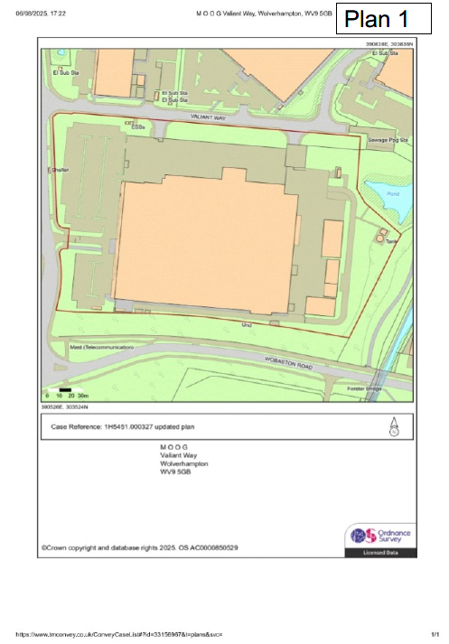

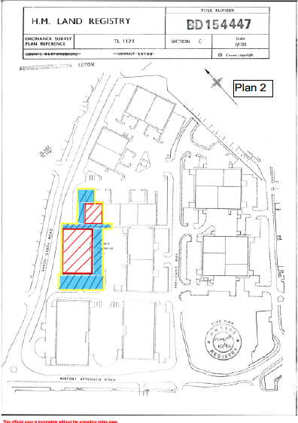

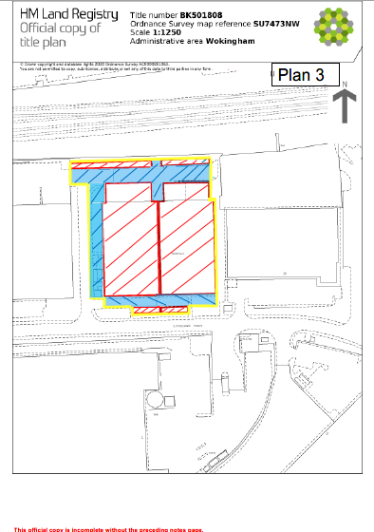

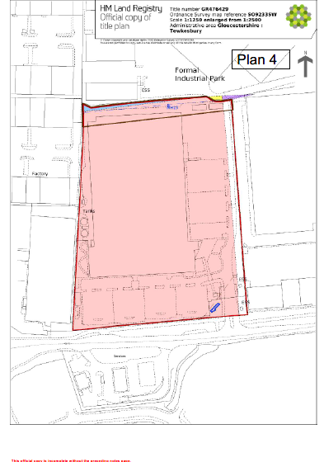

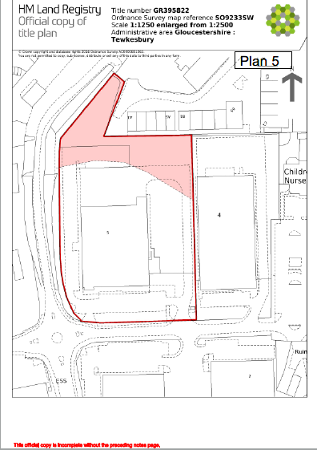

SCHEDULE 3– WARNING NOTICE
WARNING NOTICE OF COURT INJUNCTION

A HIGH COURT INJUNCTION granted by the High Court in Claim No PT-2025-000910 on 6 October 2025 and reviewed on [DATE] exists relating to the land and premises known as Moog Aircraft Group Wolverhampton, Valiant Way, Pendeford, Wolverhampton, WV9 5GB.

The injunction means you may not:

- FOR THE PURPOSE OF PROTEST OR SABOTAGE ENTER OCCUPY OR REMAIN ON THE LAND AND PREMISES SHOWN EDGED RED ON PLAN 1, INCLUDING THE PERIMETER GATES AND FENCING, BEING MOOG AIRCRAFT GROUP WOLVERHAMPTON, VALIANT WAY, WOLVERHAMPTON, WV9 5GB
- DELIBERATELY AND WITH KNOWLEGDE OF THE ORDER OBSTRUCT OR INTERFERE WITH OR ATTEMPT TO OBSTRUCT OR INTERFERE WITH ACCESS TO OR EGRESS FROM THE LAND AND PREMISES SHOWN EDGED RED ON PLAN 1
- INTERFERE OR ATTEMPT TO INTERFERE WITH ANY OF THE SERVICES SERVING THE LAND AND PREMISES SHOWN EGDED RED ON PLAN 1

ANYONE BREACHING THE TERMS OF THIS COURT ORDER OR ASSISTING ANY OTHER PERSON IN BREACHING THE TERMS OF THIS ORDER MAY BE HELD TO BE IN CONTEMPT OF COURT AND MAY BE SENT TO PRISON, FINED OR HAVE THEIR ASSETS SEIZED

A copy of the Order and the legal proceedings to which it relates (including the amendments made to the persons subject to the Order and the re-re-amended claim form and re-re-amended particulars of claim) can be viewed at www.moog.co.uk/injunction (accessible via the QR Code below) or obtained by e-mailing mooglegal@moog.com



WARNING NOTICE OF COURT INJUNCTION

A HIGH COURT INJUNCTION granted by the High Court in Claim No PT-2025-000910 on 6 October 2025 and reviewed on [DATE] exists relating to the land and premises known as Moog Controls Ltd, Units C and J Airport Executive Park, President Way, Luton, LU2 9NY

The injunction means you may not:

- FOR THE PURPOSE OF PROTEST OR SABOTAGE ENTER OCCUPY OR REMAIN ON THE LAND AND PREMISES SHOWN EDGED YELLOW ON PLAN 2 BEING MOOG CONTROLS LTD, UNITS C AND J AIRPORT EXECUTIVE PARK, PRESIDENT WAY, LUTON, LU2 9NY
- DELIBERATELY AND WITH KNOWLEDGE OF THE ORDER OBSTRUCT OR INTERFERE WITH OR ATTEMPT TO OBSTRUCT OR INTERFERE WITH ACCESS TO OR EGRESS FROM THE LAND AND PREMISES SHOWN EDGED YELLOW ON PLAN 2
- INTERFERE OR ATTEMPT TO INTERFERE WITH ANY OF THE SERVICES SERVING THE LAND AND PREMISES SHOWN EGDED YELLOW ON PLAN 2

ANYONE BREACHING THE TERMS OF THIS COURT ORDER OR ASSISTING ANY OTHER PERSON IN BREACHING THE TERMS OF THIS ORDER MAY BE HELD TO BE IN CONTEMPT OF COURT AND MAY BE SENT TO PRISON, FINED OR HAVE THEIR ASSETS SEIZED

A copy of the Order and the legal proceedings to which it relates (including the amendments made to the persons subject to the Order and the re-re-amended claim form and re-re-amended particulars of claim) can be viewed at www.moog.co.uk/injunction (accessible via the QR Code below) or obtained by e-mailing mooglegal@moog.com

WARNING NOTICE OF COURT INJUNCTION

A HIGH COURT INJUNCTION granted by the High Court in Claim No PT-2025-000910 on 6 October 2025 and reviewed on [DATE] exists relating to the land and premises known as Moog Reading Limited, 30 Suttons Business Park, Reading, Berkshire, RG6 1AW

The injunction means you may not:

- FOR THE PURPOSE OF PROTEST OR SABOTAGE ENTER OCCUPY OR REMAIN ON THE LAND AND PREMISES SHOWN EDGED YELLOW ON PLAN 3 BEING MOOG READING LIMITED, 30 SUTTONS BUSINESS PARK, READING, BERKSHIRE, RG6 1AW
- DELIBERATELY AND WITH KNOWLEGDE OF THE ORDER OBSTRUCT OR INTERFERE WITH OR ATTEMPT TO OBSTRUCT OR INTERFERE WITH ACCESS TO OR EGRESS FROM THE LAND AND PREMISES SHOWN EDGED YELLOW ON PLAN 3
- INTERFERE OR ATTEMPT TO INTERFERE WITH ANY OF THE SERVICES SERVING THE LAND AND PREMISES SHOWN EGDED YELLOW ON PLAN 3

ANYONE BREACHING THE TERMS OF THIS COURT ORDER OR ASSISTING ANY OTHER PERSON IN BREACHING THE TERMS OF THIS ORDER MAY BE HELD TO BE IN CONTEMPT OF COURT AND MAY BE SENT TO PRISON, FINED OR HAVE THEIR ASSETS SEIZED

A copy of the Order and the legal proceedings to which it relates (including the amendments made to the persons subject to the Order and the re-re-amended claim form and re-re-amended particulars of claim) can be viewed at www.moog.co.uk/injunction (accessible via the QR Code below) or obtained by e-mailing mooglegal@moog.com

WARNING NOTICE OF COURT INJUNCTION

A HIGH COURT INJUNCTION granted by the High Court in Claim No PT-2025-000910 on 6 October 2025 and reviewed on [DATE] exists relating to the land and premises known as Moog Aircraft Group Tewkesbury, Ashchurch, Tewkesbury, Gloucestershire, GL20 8NA.

The injunction means you may not:

- FOR THE PURPOSE OF PROTEST OR SABOTAGE ENTER OCCUPY OR REMAIN ON THE LAND AND PREMISES SHOWN EDGED RED ON PLAN 4, INCLUDING THE PERIMETER GATES AND FENCING, BEING MOOG AIRCRAFT GROUP TEWKESBURY, ASHCHURCH, TEWKESBURY, GLOUCESTERSHIRE, GL20 8NA
- DELIBERATELY AND WITH KNOWLEGDE OF THE ORDER OBSTRUCT OR INTERFERE WITH OR ATTEMPT TO OBSTRUCT OR INTERFERE WITH ACCESS TO OR EGRESS FROM THE LAND AND PREMISES SHOWN EDGED RED ON PLAN 4
- INTERFERE OR ATTEMPT TO INTERFERE WITH ANY OF THE SERVICES SERVING THE LAND AND PREMISES SHOWN EGDED RED ON PLAN 4

ANYONE BREACHING THE TERMS OF THIS COURT ORDER OR ASSISTING ANY OTHER PERSON IN BREACHING THE TERMS OF THIS ORDER MAY BE HELD TO BE IN CONTEMPT OF COURT AND MAY BE SENT TO PRISON, FINED OR HAVE THEIR ASSETS SEIZED

A copy of the Order and the legal proceedings to which it relates (including the amendments made to the persons subject to the Order and the re-re-amended claim form and re-re-amended particulars of claim) can be viewed at www.moog.co.uk/injunction (accessible via the QR Code below) or obtained by e-mailing mooglegal@moog.com.

WARNING NOTICE OF COURT INJUNCTION

A HIGH COURT INJUNCTION granted by the High Court in Claim No PT-2025-000910 on 6 October 2025 and reviewed on [DATE] exists relating to the land and premises known as Moog Industrial Group, Ashchurch Parkway, Tewkesbury, Gloucestershire, GL20 8TU

The injunction means you may not:

- FOR THE PURPOSE OF PROTEST OR SABOTAGE ENTER OCCUPY OR REMAIN ON THE LAND AND PREMISES SHOWN EDGED RED ON PLAN 5 BEING MOOG INDUSTRIAL GROUP, ASHCHURCH PARKWAY, TEWKESBURY, GLOUCESTERSHIRE, GL20 8TU
- DELIBERATELY AND WITH KNOWLEDGE OF THE ORDER OBSTRUCT OR INTERFERE WITH OR ATTEMPT TO OBSTRUCT OR INTERFERE WITH ACCESS TO OR EGRESS FROM THE LAND AND PREMISES SHOWN EDGED RED ON PLAN 5
- INTERFERE OR ATTEMPT TO INTERFERE WITH ANY OF THE SERVICES SERVING THE LAND AND PREMISES SHOWN EGDED RED ON PLAN 5

ANYONE BREACHING THE TERMS OF THIS COURT ORDER OR ASSISTING ANY OTHER PERSON IN BREACHING THE TERMS OF THIS ORDER MAY BE HELD TO BE IN CONTEMPT OF COURT AND MAY BE SENT TO PRISON, FINED OR HAVE THEIR ASSETS SEIZED

A copy of the Order and the legal proceedings to which it relates (including the amendments made to the persons subject to the Order and the re-re-amended claim form and re-re-amended particulars of claim) can be viewed at www.moog.co.uk/injunction (accessible via the QR Code below) or obtained by e-mailing mooglegal@moog.com:

